Learn to shine, living and working in your new career overseas.

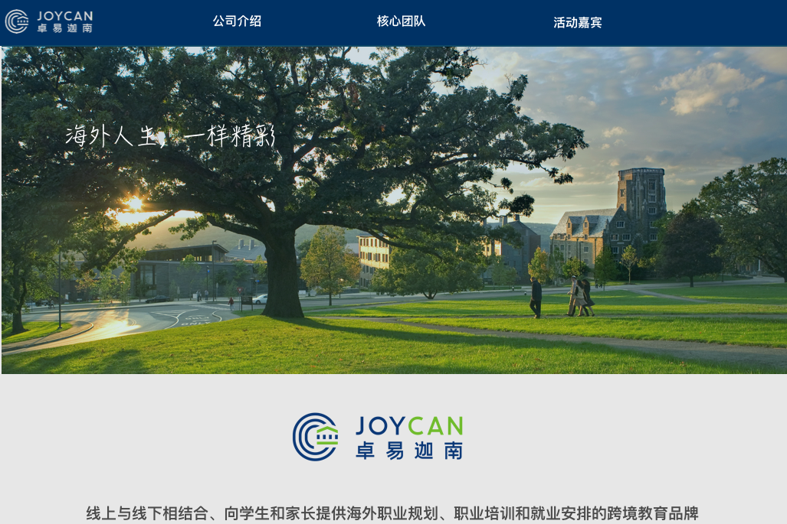

We incorporate both online and offline advantages, providing training and consultation to young jobseekers and their parents.